Djerriwarrh Festival 2023   
Pet Expo Application Form

Saturday 11 November 2023

Melton

|  |
| --- |
| Please read the attached terms and conditions carefully. If you have any questions or require further information, phone the Animal Management team on 9747 7200  Applications close strictly at 5pm, Friday 18 August 2023 |

Please return your completed form and supporting documentation to:

**Mail: Email: Phone:**

Team Leader, Ranger Services JohnFl@melton.vic.gov.au 9747 7200  
PO Box 21, (max. file size: 5MB) **Fax:**

Melton VIC 3337 9743 9970

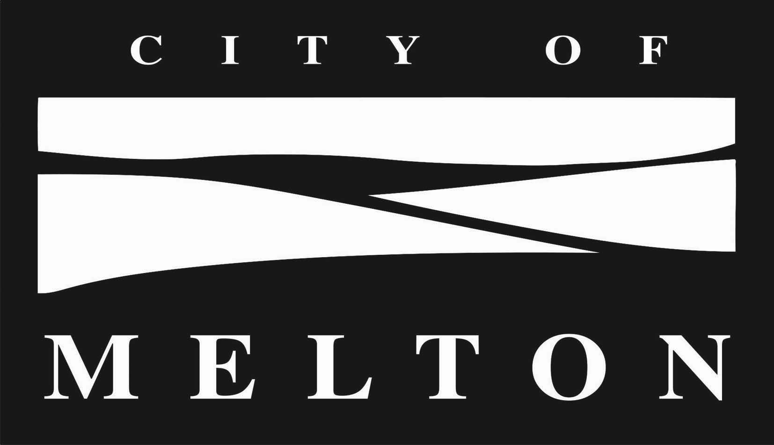

|  |  |  |  |  |  |  |  |  |  |  |  |
| --- | --- | --- | --- | --- | --- | --- | --- | --- | --- | --- | --- |
| 1.Your details | | | | | | | | | | | |
| Applicant’s name |  | | | | | | | | | | |
| Business or group name |  | | | | | | ABN | |  | | |
| Mailing address |  | | | | | | | | | | |
|  |  | | | | | | | | Postcode | |  |
| Business address |  | | | | | | | | | | |
|  |  | | | | | | | | Postcode | |  |
| Phone number |  | | | Mobile number | | | |  | | | |
| Email address |  | | | Web site | | | |  | | | |
| Event day contact person |  | | | Mobile number | | | |  | | | |
| Public Liability Insurer |  | | | Policy Expiry date | | | |  | | | |
|  |  | | | | | | | | | | |
| 2.Stall details | | | | | | | | | | | |
| Number of sites required |  | (1 site = 3m x 3m in size) | | | | | | | | | |
| Width (frontage) required | m | | Length | | m | | |  | |  | |
| Will you be providing your own temporary structure? | | | | | | Yes  No | | | | | |
| Structure’s must be weighted appropriately (minimum of 25kgs per leg), should your structure cause any damage or injury you will be directly responsible. Please note that Melton City Council will not provide any temporary structures (unless otherwise discussed). | | | | | | | | | | | |
| Is vehicle access required?  Only one car is permitted on-site access at the event. Vehicles are only permitted on site during bump-in and bump-out. Access between 11am – 5pm is strictly prohibited. | | | | | | Yes  No | | | | | |
| Please provide an overview of what you will be doing or what activity you will be facilitating at your stall | | | | | | | | | | | |
|  | | | | | | | | | | | |

|  |  |  |  |  |  |  |  |
| --- | --- | --- | --- | --- | --- | --- | --- |
| Would you like to also provide a demonstration in our Pet Expo Activity ring? If so, our team will be in touch for further information | | | Yes  No | | | | |
|  |  | | | | | | |
| 3. Melton City Council Upholding of Child Safe Standards | | | | | | | |
| Melton City Council have adopted a Child Safe Policy and Procedure. As part of this policy we need all contractors and event vendors to agree to the terms of the Child Safe Code of Conduct.  You will need to familiarise yourself with the document below.   * Child Safe Policy and Procedure   By signing the principal’s indemnity below, you acknowledge that you have read and will comply with these documents.  These documents can be found at <https://www.melton.vic.gov.au/Out-n-About/Events/Get-involved-in-Council-events> | | | | | | | |
|  | | | | | | |
| 4.Supporting Documentation | | | | | | |
| Please complete the following checklist and ensure that you provide all the required supporting documentation with your completed application form.  **Checklist (please tick):**  Please attach the following documentation to your completed application form:  A copy of your current Working with Children Checks (and/or that of any others who will be performing/present at the event).  A photo of your set-up.  A copy of your public liability insurance Certificate of Currency not less than $10 million – valid up to and including the event date.  You acknowledge that you have read and will comply with the documents listed in Section 3. Melton City Council Upholding of Child Safe Standards. | | | | | | |
| 5.Further information: Pet Expo Stalls | | | | | | | |
| 1. Pet expo stalls are solely for the promotion of quality, services and products relating directly to animals and pets. NO second-hand goods are permitted. 2. All pet expo stalls are to be well presented and tidy at all times. 3. Each pet expo stall site is approximately 3 x 3 metre in size. 4. Pet expo stall holders are required to supply their own equipment (ie. shade structure, marquee, tables, chairs, tarpaulins etc). 5. All shade structures and canopies are to be weighted down, pegging into the ground is only permitted with the approval from the events team. All weights are to be a minimum of 25kg per leg. 6. All items and stock must remain within the boundaries of your site at all times. 7. Pet expo stalls will be situated on grass or gravelled surfaces. 8. No power or water is available for use by pet expo stall holders, unless organised with Local Laws. 9. Livestock and animals must be restrained **at all times**. 10. Vehicle access between 11am – 5pm to the site is strictly prohibited. 11. Stall holders are not permitted to bump out earlier than official trading hours. Times will be confirmed closer to the festival. 12. Strictly NO use of stakes/ tent pegs will be permitted to secure any temporary infrastructure or display material. | | | | | | | |
| 6.Principal’s Indemnity | | | | | | | |
| The applicant agrees to abide by all terms and conditions attached and to indemnify and keep indemnified the Principal, its servants and agents, from and against all actions, costs, claims, charges, expenses, penalties, demands and damages whatsoever that may be brought or made or claimed against them, or arising from my performance or purported performance of its obligations and directly related to the negligent acts, errors or omission by the applicant and their involvement with the 2023 Djerriwarrh Festival. | | | | | | | |
| Signature of applicant | | | | Date | |  | |
|  | | |  | |  | | |
|  | |  | | | | | |
| **Privacy Statement:** The personal information requested on this form is collected by Melton City Council for the purpose of coordinating the Djerriwarrh Festival. The information will be kept confidential and identifying information will not be disclosed to any person for any other purpose. You may access your own information by contacting Melton City Council’s Customer Engagement Unit on 9747 7200. | | | | | | | |
|  | |  | | | | | |

|  |
| --- |
| 7.Terms and conditions |

1. Please note that Djerriwarrh Festival will be held following the COVIDSafe guidelines and recommendations which are current at the time. As these guidelines are constantly changing, we will touch base with you closer to the event with any requirements and/or documentation we need to follow. This may include, but is not limited to, mask, check in and vaccination requirements.
2. Pet Expo stall sites will be available on Saturday 11 November 2023 only for the sale of quality animal and pet related items.
3. Operating hours on Saturday 11 November 2023 will be 12.00pm – 5.00pm (these times may be subject to change).
4. All applications are subject to a selection process with applications closing at 5pm, Friday 7 July 2023. Successful applicants will be notified shortly after. Unsuccessful applicants will also be notified within this time.
5. It is the Pet Expo stall holder’s responsibility to provide all necessary equipment and facilities.
6. Stalls may be situated on a grassed or graveled area, which will require weights (no pegging).
7. All items must be well presented and must remain within the boundaries of your site.
8. Stall holders must at all times comply with all laws, regulations and requirements of local Government and other statutory authorities.
9. Stall holders must not transfer, sub-let, assign or in any other manner or form dispose of its space leased for the Festival. No market stall holder will be permitted to operate within the festival precinct without prior arrangement with Melton City Council.
10. Melton City Council will not accept any responsibility for the safety of any article or product of any kind brought by the stall holder into the 2023 Djerriwarrh Festival.
11. Stall holder hereby indemnifies Melton City Council and holds Melton City Council harmless in respect to all costs, claims, demands and expenses to which the festival may in any way be subjected to as a result of any loss or injury to any person or company including members of the public, the staff or authorities, the festival or stallholders, employees, servants, agents and invitees howsoever caused as a result of any act, neglect or default by the stall holder. Market stall holders with staff must have the appropriate Work Cover policies in place.
12. Melton City Council shall not be responsible for any loss of any nature including monies paid to Melton City Council, suffered by any Pet Expo stall holder from any restrictions or conditions which prevent the construction, erection, completion, alteration or dismantling of any stall or exhibit or for the setting up or removal of any products, for the failure of any services available to the Pet Expo stall holder, or for any cancellation or restriction in opening hours at the Djerriwarrh Festival as a result of any circumstances not within the direct control of the festival.
13. The Pet Expo stall holder must at all times conduct their stall so as not to interfere with any other market stall. Any decision of Melton City Council in this regard shall be final and binding. Melton City Council reserves the right to remove the stallholder at their cost.
14. The stall holder may not conduct lotteries, raffles or competitions without the consent of Melton City Council.
15. The display, sale or distribution of counterfeit or illegal goods is not permitted nor is the display, sale or distribution of religious or political material.
16. The sale of inappropriate material, including replications, pictures or printing of naked body parts and obscene and offensive language are not permitted.
17. Melton City Council reserves the right to alter the layout, plans and positions of the Pet Expo stalls if, in its opinion any alteration is desirable for the benefit or the Djerriwarrh Festival as a whole.
18. Without the written consent from Melton City Council, the stall holder shall not use any microphone, sound amplification or musical instrument. If allowed, noise levels will be subject to, and set, at Melton City Council’s discretion.
19. Melton City Council shall have the right to postpone or amend the time the Djerriwarrh Festival is held to any other time which, in the opinion of the festival, is more suitable for the Djerriwarrh Festival and will not be responsible for any loss occasioned thereby. The failure of any electrical generating or other equipment at any and all times during the course of the Djerriwarrh Festival, the Melton City Council shall not be held responsible and will not be responsible for any loss occasioned thereby. Melton City Council shall further have the right to alter the opening times, closing times for the duration of the Djerriwarrh Festival and will not be responsible for any loss occasioned thereby.
20. Stall holders acknowledge that all rights in relation to any photographs, films, videos or sound recording of the Djerriwarrh Festival, or any part thereof including the entertainment stages or performers, are the exclusive property of Melton City Council and that without the written consent of Melton City Council no stall holder is able to make any photograph, film, video or sound recording.
21. Please be aware that Melton City Council is commissioning professional photography for the Djerriwarrh Festival. Your photo may be taken during the course of the event and any images captured will not be used for commercial purposes. Images taken at the Djerriwarrh Festival may be used in future Melton City Council event publications and promotional material.
22. Any Pet Expo stall holder causing any damage to the environment and/or any building surrounds will be fully liable for any costs incurred. Strictly **NO** use of stakes or tent pegs will be permitted to secure marquees, canopies and any other infrastructure or display material.
23. Melton City Council is not responsible for any warranties, promises or agreements made by stall holders in relation to stalls or their products

Electrical Supplies

* Power is **not available** to any stall sites.
* No extra generators are to be used unless discussed in advance and approved by Melton City Council.
* Only tagged and tested appliances and leads are allowed (non tagged and tested appliances and leads may be confiscated and returned after the event).
* Readily inflammable materials are not to be used in the decorating of your site or in the construction of same and all fire safety rules must be followed and no toxic waste of fumes should emit from your site.

Vehicles

* Stall holders are **not permitted** to bump out earlier than official trading hours. Times will be confirmed closer to the festival.
* Stock can only be wheeled to your stall during the festival operating hours. There is no direct access to market stalls by vehicles. Bump in and bump out times will be provided closer to the event.
* A vehicle pass will be provided to stall holders in their event pack closer to the event.

Insurance

* It is compulsory for all market stall holders to have their own Public Liability. A copy of your Certificate of Currency must be provided with your application. (Not less than $10 million) Applicants will not be considered if they do not have the required insurance cover.

Waste

* Melton City Council encourages the reduction of waste at our events. We ask that stallholders use environmentally friendly packaging where possible.

Single-Use Plastic Ban

* From 1 February 2023, problematic single-use plastics will be banned from sale or supply in Victoria. Please refer to link provided for further information. [Reducing plastic pollution starts with us | Victorian Government (www.vic.gov.au)](https://www.vic.gov.au/single-use-plastics). It is expected that all participates at our events comply with this government requirement.

Balloons

* Balloons (in any form) are not allowed at any of our events and therefore we ask that you do not include them in the decoration of your stall, included in any giveaways and/or handed out uninflated. Most councils are aligned with this now given their impact on the environment.