Djerriwarrh Festival 2023   
Get Active Expo Application Form

Saturday 11 November 2023

Melton

|  |
| --- |
| Please read the attached terms and conditions carefully. If you have any questions or require further information, phone the Recreation Development Officer on 9747 7200.  Applications close strictly at 5pm, Friday 18 August 2023 |

|  |  |  |  |  |  |  |  |
| --- | --- | --- | --- | --- | --- | --- | --- |
| 1.Your details | | | | | | | |
| Applicant’s name |  | | | | | | |
| Business Name |  | | | ABN | |  | |
| Group Name |  | | | ABN | |  | |
| Mailing address |  | | | | | | |
|  |  | | | | | Postcode |  |
| Business address |  | | | | | | |
|  |  | | | | | Postcode |  |
| Phone number |  | | Mobile number | | |  | |
| Email address |  | | Web site | | |  | |
| Event day contact person |  | | Mobile number | | |  | |
| Public Liability Insurer |  | | Policy expiry date | | |  | |
|  |  | | | | | | |
| 2.Site details | | | | | | | |
| What size site do you require?  Requests for sites larger than 10m by 10m may be approved depending on availability | | Small (5m x 5m)  Standard (10m x 10m)  Large (15m x 15m) | | | | | |
| Is vehicle access required?  Only one car is permitted on-site access at the event. Vehicles are only permitted on site during bump-in and bump-out. Access between 11am – 5pm is strictly prohibited. | | | | | Yes  No | | |

Please return your completed form and supporting documentation to:

**Mail: Email: Phone:**

Recreation Development Officer nicolew@melton.vic.gov.au 9747 7200  
PO Box 21, (max. file size: 5MB) **Fax:**

Melton VIC 3337 9743 9970

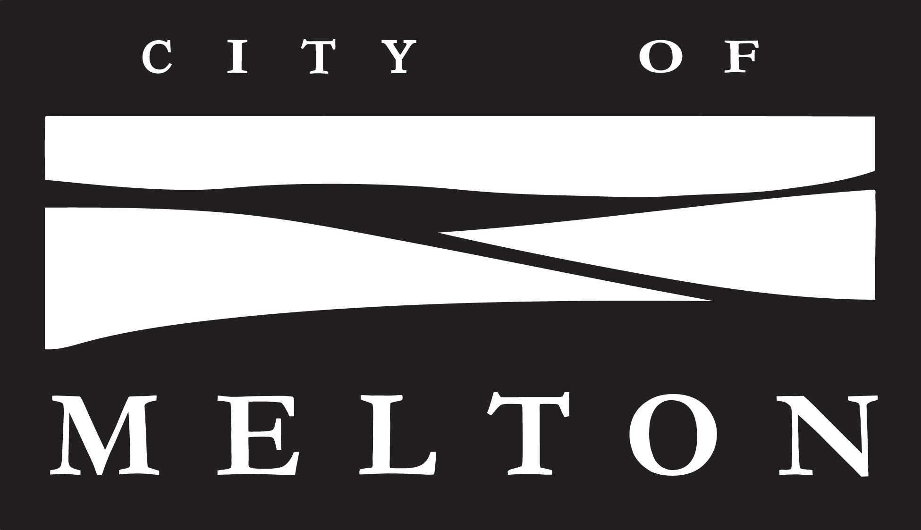

|  |  |  |
| --- | --- | --- |
| 3.Site details continued | | |
|  |  | |
| Please provide a description of the activities you expect to carry out on your site and how you will utilise the space requested in section 2. **(Please note: sites must provide interactive activities)** | | |
|  | | |
|  | | |
|  | | |
|  | | |
|  | | |
|  |  | |
| Please list all the equipment you will be bringing on site **(note: no power is available on site)** | | |
|  | | |
|  | | |
|  | | |
|  | | |
| Will you be providing your own temporary structure? | | Yes  No |
| Structure’s must be weighted appropriately (minimum of 25kgs per leg), should your structure cause any damage or injury you will be directly responsible. Please note that Melton City Council will not provide any temporary structures (unless otherwise discussed). | | |

|  |  |  |  |  |
| --- | --- | --- | --- | --- |
|  |  | | | |
| 4.Melton City Council Upholding of Child Safe Standards | | | | |
| Melton City Council have adopted a Child Safe Policy and Procedure. As part of this policy we need all contractors and event vendors to agree to the terms of the Child Safe Code of Conduct.  You will need to familiarise yourself with the document below.   * Child Safe Policy and Procedure   By signing the principal’s indemnity below, you acknowledge that you have read and will comply with these documents.  These documents can be found at <https://www.melton.vic.gov.au/Out-n-About/Events/Get-involved-in-Council-events> | | | | |
| 5.Further Information | | | | |
| In order to provide an effective and sustainable solution for the set-up display of the Get Active Expo stalls, in completing the application form please note the following:   1. Get Active Expo stall sites are allocated up to approximately 10 x 10 metre space (larger stalls based on approval) 2. All items and stock must be well presented and remain within the boundaries of your site at all times. 3. Get Active Expo stall holders are required to supply their own infrastructure and display equipment i.e. notice boards, banners etc, as listed in the application form and approved by the Recreation Development Officer 4. All shade structures and canopies are to be weighted down, pegging into the ground is only permitted with the approval from the events team. **All weights are to be a minimum of 25kg per leg.** 5. The distribution of religious or political material by Get Active Expo stall holders is not permitted 6. Get Active Expo stalls will be situated on grass or gravelled surfaces. 7. No power or water is available for use by Get Active Expo stall holders, unless discussed. 8. Vehicle access between 11am – 5pm to the site is strictly prohibited. 9. Stall holders are not permitted to bump out earlier than official trading hours. Times will be confirmed closer to the festival. 10. Strictly NO use of stakes/ tent pegs will be permitted to secure any temporary infrastructure or display material. | | | | |
| 6.Supporting documentation | | | | |
| Please complete the following checklist and ensure that you provide all the required supporting documentation with your completed application form.  **Checklist (please tick):**  Please attach the following documentation to your completed application form:  A copy of your current Working with Children Checks (and/or that of any others who will be performing/present at the event).  A copy of your public liability insurance Certificate of Currency – valid up to and including the date of the event you wish to attend.  You acknowledge that you have read and will comply with the documents listed in Section 4. Melton City Council Upholding of Child Safe Standards. | | | |
| 7.Principal’s Indemnity | | | | |
| The applicant agrees to abide by all terms and conditions attached and to indemnify and keep indemnified the Principal, its servants and agents, from and against all actions, costs, claims, charges, expenses, penalties, demands and damages whatsoever that may be brought or made or claimed against them, or arising from my performance or purported performance of its obligations and directly related to the negligent acts, errors or omission by the applicant and their involvement with the 2023 Djerriwarrh Festival. | | | | |
| Signature of applicant | |  | Date | |
|  | |  |  | |
| **Privacy Statement:** The personal information requested on this form is being collected by Council for the purpose of coordinating the Djerriwarrh Festival. The information will be kept confidential and identifying information will not be disclosed to any person for any other purpose. You may access your own information by contacting Council's Customer Engagement unit on 9747 7200. | | | | |

|  |
| --- |
| 8. Terms and conditions |

1. Please note that Djerriwarrh Festival will be held following the COVIDSafe guidelines and recommendations which are current at the time. As these guidelines are constantly changing, we will touch base with you closer to the event with any requirements and/or documentation we need to follow. This may include, but is not limited to, mask, check in and vaccination requirements.
2. All applications are subject to a selection process with applications closing Friday 7 July 2023. Notification to successful applicants will then be made within two weeks. Unsuccessful applicants will also be notified within this time.
3. Note that the Get Active Expo will be on a grass surface.
4. All items must be well presented and must remain within the boundaries of your site.
5. Get Active Expo stall holders must at all times comply with all laws, regulations and requirements of local Government and other statuary authorities.
6. The Get Active Expo stallholder must not transfer, sub-let, assign or in any other manner or form dispose of its space leased from the Festival.
7. The festival management will not accept any responsibility for the safety of any article or product of any kind brought by the Get Active Expo stall holder into the Festival.
8. The Get Active Expo stall holder hereby indemnifies the festival and holds the festival harmless in respect to all costs, claims, demands and expenses to which the festival may in any way be subjected as a result of any loss or injury to any person or company including members of the public, the staff or authorities, the festival or stallholders, employees, servants, agents and invitees howsoever caused as a result of any act, neglect or default by the stallholder. Get Active Expo stall holders with staff must have the appropriate Work Cover policies in place.
9. The festival shall not be responsible for any loss or any nature including monies paid to the festival, suffered by any stall holder from any restrictions or conditions which prevent the construction, erection, completion, alteration or dismantling of any stall or exhibit or for the setting or removal of any products, exhibits and/or van or for the failure of any services available to the Get Active Expo stall holder, or for any cancellation or restriction in opening hours at the Djerriwarrh Festival as a result of any circumstances not within the direct control of the festival.
10. The Get Active Expo stall holder must at all times conduct their site so as not to interfere with any other market stall. Any decision of the festival in this regard shall be final and binding. The festival reserves the right to remove the stallholder and its exhibition at their cost.
11. The Get Active Expo stall holder may not conduct lotteries, raffles or competitions without the consent of the festival management.
12. The display, sale or distribution of counterfeit or illegalgoods is not permitted nor is the display, sale or distribution of religious or political material.
13. The festival reserves the right to alter the layout, plans and positions of the displays Get Active Expo stalls and/or van sites if, in its opinion, any alteration is desirable for the benefit of the festival as a whole.
14. Without the written consent of the festival, the Get Active Expo stall holder shall not use any microphone, sound amplification or musical instrument and if allowed, noise levels will be subject to and/or set at the festivals discretion.
15. The festival shall have the right to postpone or amend the time for the holding of the festival to any other time which, in the opinion of the festival, is more suitable for the festival and will not be responsible for any loss occasioned thereby. The festival shall further have the right to alter the opening times, closing times duration of the Djerriwarrh Festival and will not be responsible for any loss occasioned thereby.
16. Get Active Expo stall holders acknowledge that all rights in relation to any photographs, films, videos or sound recording of the festival, or any part thereof including the entertainment stage(s) or performers, are the exclusive property of the festival and that without the written consent of the festival no Get Active Expo stall holder is able to make any photograph, film, video or sound recording. Get Active Expo stall holders hereby consent to and authorize the Festival to make and use any photograph, film, video or sound recording of the festival or any part thereof, including any part of any Get Active Expo stall display, demonstration, stall and/or van.
17. Any Get Active Expo stall holder causing any damage to the environment and/or any building surroundings will be fully liable for any costs incurred. Strictly **NO** use of stakes/ tent pegs will be permitted to secure any temporary infrastructure or display material.
18. Any Get Active Expo stall holder causing damage and/or loss to and of any part of the stall signage or infrastructure supplied by the Festival and/or any of the Festivals sponsors, stall frame and/or covering material or to any furnishings and/or electrical equipment provided by the festival through the appointed equipment hire company/electrical contractor will be fully liable for any costs incurred for the repair and/or replacement of the damaged and/or lost equipment.
19. The festival is not responsible for any warranties, promises or agreements made by Get Active Expo stall holders in relation to stalls or their products.
20. The Festival reserves the right to reject any application.

Vehicles

* Get Active Expo stall holders are not permitted to bump out earlier than official trading hours. Times will be confirmed.
* Stock can only be wheeled to your stall during the festival operating hours. There is no direct access to Get Active Expo by vehicles. Bump in and bump out times will be provided at a later stage.
* Vehicles passes will be provided to Get Active Expo stall holders.

Insurance

* It is compulsory for all Get Active Expo stall holders to have their own Public Liability. A copy of your Certificate of Currency must be provided with your application. (Not less than $10 million) Applicants will not be considered if they do not have the required insurance cover.

Waste

* Melton City Council encourages the reduction of waste at our events. We ask that stallholders use environmentally friendly packaging where possible.

Single-Use Plastic Ban

* From 1 February 2023, problematic single-use plastics will be banned from sale or supply in Victoria. Please refer to link provided for further information. [Reducing plastic pollution starts with us | Victorian Government (www.vic.gov.au)](https://www.vic.gov.au/single-use-plastics). It is expected that all participates at our events comply with this government requirement.

Balloons

* Balloons (in any form) are not allowed at any of our events and therefore we ask that you do not include them in the decoration of your stall, included in any giveaways and/or handed out uninflated. Most councils are aligned with this now given their impact on the environment.