
Welcome to the 2016 Djerriwarrh Festival!!! Please find below information about this year’s event.
For regular Djerriwarrh Festival updates on performances and event day activities, LIKE us on Facebook.com/djerrifestival or head to melton.vic.gov.au

GENERAL INFORMATION

Date: Saturday 5 November 2016
Time: 11am Street Parade
12pm – 10pm
(Fireworks finale will be at approx 10pm)

Please note: fireworks and bonfire are weather dependent.

Location: Melton Recreation Reserve, Reserve Road, Melton, Mel Ref 337 C9 D9

Event times
11am Street Parade
12pm – 10pm Festival program
11am – 11pm Lions Club Carnival

2016 festival partners
We are pleased to announce that Woodgrove and Injury Advice Line Lawyers are back onboard as our community sponsors and welcome Mercedes-Benz Melbourne as a new festival friend. All will be present on the day – be sure to say g’day!
ENTRY
This is a free community event with a range of free children activities and entertainment. Please note that carnival rides and amusements are charged and ride tickets cannot be pre-purchased.

WHAT’S ON

11am | Story Time Street Parade  Lion’s Club Carnival (until 11pm)
12pm – 5pm | Get Active Expo  Pet Expo for your furry, feathered and scaly friends  Community Info Zone  Melton Rotary Car Chow  Buskers Tree  Djerriwarrh Youth Services  Community Showcase Ring  Market Stall Village  Intercultural Communities  Tiny Tots (free rides for the wee ones)
7.45pm | Djerriwarrh Festival BONFIRE (new)
4.30pm-10pm | Main stage entertainment
10pm | Woodgrove fireworks
12pm-10pm | International Food Bazaar (food court)

WHAT’S NEW IN 2016?

- A BIGGER THAN EVERY BEFORE MARKET STALL VILLAGE featuring over 60 stalls with something for EVERYBODY!!!
- MORE TINY TOT TOWN rides and amusements for the little ones FREE!
- THE BONFIRE IS BACK!! After many years absent, the original and traditional Djerriwarrh Festival bonfire is back, bigger than ever! Harking back to the historical and nostalgic roots of the festival, this inclusion has huge contemporary appeal for newer members of the community and will be enjoyed by young and old.
- MULTICULTURAL PRECINCT to showcase traditional dance, food and music to celebrate Melton’s diversity and engage locals with people and culture from all over the world.

The Street Parade @ 11am

Where is the best place to watch the parade?
The best place to watch the parade is along High Street between Palmerston and Coburns Road. In 2016, the Street Parade route will return to its original length.

What this the theme of this year’s Street Parade?
Story Time is this year’s Street Parade theme.

I’m participating in the Street Parade. When is the mandatory safety briefing?
A representative from each entry is required to attend a mandatory safety briefing at the Civic Centre, 232 High Street, Melton on 5 October 2016 at 6.30pm.

So far, our 2016 Street Parade entries include:
The Melton CFA | Baha'l Community of Melton | Coburn Primary School | Diggers Rest Junior Football
Exford Primary School | Feel the Beat Dance Academy | Filipino Friendship Group | Kurunjang Primary School
Heathdale Christian College | Kakoshke Racing Team | Busyfeet Melton | Melton Basketball Association
Arnolds Creek Primary School | Ambulance Historical Society of Victoria | Melton Broncos Rugby League Club Inc | Melton & District 4WD Club Inc
Lions Clubs of Melton | Melton Junior Football Netball Club | Melton Festival for Healthy Living | Melton Dog Obedience Club
Melton Phoenix FC | Melton Primary School | Melton South Primary School | Melton Uniting Kindergarten
Melton SES | NRG Dance Studio | Paul Sadler Swimland Melton | Saint Catherine of Siena Primary School
St Dominic's Primary School Melton | Scouts Victoria, Djerriwarrh District | St Anthony of Padua Primary School | Swimmers
Te Karangatahi Inc | Utsav Malayalee Samaj | Melton Hockey Club | Western Vehicle Restorers Club
Melton Bangla School

Lions Club Carnival
When does the Lions Club Carnival start and finish?
The Lions Club Carnival kicks off Friday, 4 November around 6pm.
On event day, the Carnival begins at 11am and ends at 11pm. The Carnival will operate on the Sunday until around 4pm.

Got a question about The Lions Club Carnival?
All queries about the carnival should be emailed to Arthur Uren from The Lions Club of Melton at aur89696@bigpond.net.au

PERFORMANCE PROGRAMS
Musical performances
The bumper main stage program will be headlined by 70/80’s sensation Dragon and backed up by Eurogliders, Sarah McLeod (from The Super Jesus), Reuben Stone and Kite Machine. Main stage entertainment kicks off at 4.30pm with kiddie favourites The Mik Maks and will finish with a spectacular fireworks show as always. We also welcome up and coming Aussie talents Ariela Jacobs, Anna O and Josh Cashman who will play rotationally at The Buskers Tree throughout the day.

Main stage program

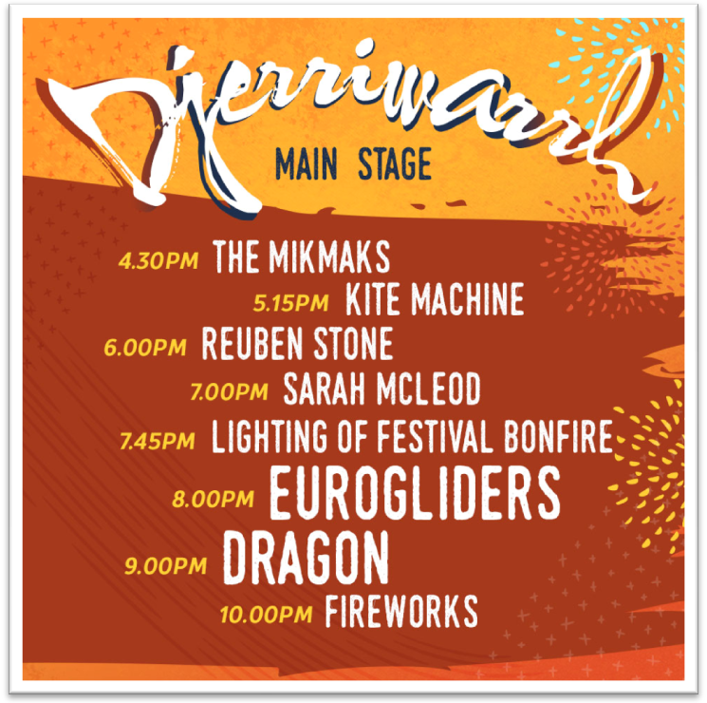

Fireworks at approx 10pm are weather dependent
Buskers Tree performances
Time | Act/performer
12pm | Ariela Jacobs
12.50pm | Josh Cashman
1.40pm | Anna O
2.30pm | Ariela Jacobs
3.20pm | Josh Cashman
4.10pm | Anna O

Community showcase program (12-5pm)
Come and be entertained by some of the finest talent Melton has to offer. :
Time on | Organisation/performer
12.00pm | Melton Music
12.20pm | Bhutanese Group
12.40pm | The Sad Bois
12.50pm | Feel the Beat
1.00pm | Urban Nation
1.15pm | Melton Festival for Healthy Living
1.30pm | Instyle Dance Co
1.45pm | Utsav Malayalee Samaj Dance
2.00pm | Kaitlyn Dando
2.10pm | Filipino Friendship Group
2.25pm | Bey Dance
2.40pm | Mecca Incorp
2.55pm | Mabuhay Dance Group
3.10pm | Bey Dance
3.30pm  3.45pm | Galactic Dance  The Melton Singers
Intercultural Communities Performance Program
12.00pm Tabla and Indian Dance
12.20pm Samoan Dance
12.40pm The Aboriginal Dance Crew
1.10pm Utsav Malayalee Samaj
1.30pm Accordion by the Chinese Group
1.50pm Fijian Dance Crew
2.10pm Alfira O’Sullivan – Suara Indonesia Dance performance & workshop
2.40pm Macedonian Group
3.00pm African Drumming Performance and Workshop
3.50pm Chinese Lion
4.20pm Global Grooves

Bonfire and fireworks
Where is the best place to see the bonfire and the fireworks display?
The best place to view both the bonfire and firework is from the main stage area.

When does the bonfire lighting occur?
The bonfire will be lit at 7.45pm.
The fireworks finale kicks off at 10pm.

Please note: both the fireworks display and bonfire are weather dependent. Council is committed to providing a safe event for the community to enjoy.

FESTIVAL FEATURE EXPOS AND ATTRACTIONS
Get Active Expo on the oval (12-5pm)
The Get Active Expo promotes active and healthy lifestyles to all residents through interactive activities. Register on the day to receive your sport passport. Participate in all activities to go into the draw for prizes. Challenge yourself on the abseiling wall, try your skills with a hockey stick, tackle a rugby league bag, jump, skip, hop and throw your way through an obstacle course and more.... The expo also links residents into local sporting and recreation clubs and gives clubs an opportunity to recruit new participants, members and volunteers from the community.
Other oval features (12-5pm):
- Community/Council Information Hub
- Intercultural area:
  - A dedicated space showcasing traditional dance, food and music to celebrate Melton’s diversity that engages locals with people and culture from all over the world.
- Pet Expo
  - Includes microchipping, pet adoption and displays. For more programming updates, please check our Facebook page regularly.
- Melton Rotary Car Show
Youth Services – NEW LOCATION
DJs, roaming performers, skate, BMX and scooter comps, free food, prizes and more...
This is a fully supervised, alcohol and drug free event brought to you by Melton Youth Services.

ROAD CLOSURES AND TIMES
HANNAH WATTS PARK AND CAR PARK WILL BE CLOSED TO THE PUBLIC FROM 5PM. Access to the Hannah Watts car park is reserved only for festival suppliers and personnel until 5pm.

Parking is prohibited along High St from Melton Valley Hwy and Smith St, including Yuille St, on Saturday 5 November from 6am to 11pm.

The following traffic restrictions will apply on the day
5.30am – 10am traffic restrictions
1. High St from Coburns Rd to Station Rd/O’Neills Rd
2. High St from Station Rd/O’Neills Rd to Alexandra St
3. High St from Alexandra St to Palmerston St
4. High St from Palmerston St to Yuille St
5. McKenzie St from Smith St to Palmerston St
6. Henry St from Palmerston St to Smith St

10am – 2pm Street Parade
1. Full closure of High St from Coburns Rd to Yullie St
2. Full closure of Station Rd/O’Neills Rd from McKenzie to Unitt St
3. Full closure of Alexandra St from McKenzie to Unitt St
4. Full closure of Palmerston St from McKenzie St to Unitt St, with access to Bakery Square from McKenzie St end
5. Full closure of Smith St from Unitt St to McKenzie St
6. Full closure of Nixon St from Smith St to Reserve Rd

5pm – 12am Fire works
1. Full closure of Nixon St from Smith St to Reserve Rd
2. Full closure of High St from Melton Valley Hwy and Smith St, including Yuille St

10am – 10.30pm Event
1. Full closure of Nixon St from McKenzie St to Reserve Rd

PARKING AND PUBLIC TRANSPORT
Where can the public park their vehicles?
The public can park anywhere near the event site as long as they follow road regulations and don’t block residential or business driveways. Please note the road closures and times.

We encourage you to travel green and use PT. Less hassle, less fuss.

Is there public transport available?
Yes, buses are running on normal Saturday timetables, however some routes will be affected by the Parade road closures. For information, call Public Transport Victoria on 1800 800 007 or visit ptv.vic.gov.au .
Additional services have been arranged, departing Palmerston Street Terminus from 10pm, 10.40pm, 11.20pm and midnight, stopping at all bus stops along routes 453T, 455T, 457T, 458T

Is there any designated ACCESS parking?
Yes. Easy access parking is available atthe front of the Willows Historical Park on Nixon Street. Vehicles displaying their accessible permit will gain entry.

Will first aid be on site?
Yes, we will have first aid services on site for the duration of the event. Please refer to our festival brochure map. You can pick one up on the day from our Information Booth, located at the oval entrance!

Will police be present?
Yes, Victoria Police will be present for the total duration of the event.

Will additional toilets be available?
Yes, additional accessible toilets will be brought in for the duration of the event.

Does the event have baby change and breast feeding facilities?
Yes, baby change and breast feeding facilities will be available at the event.

Will there be a lost children’s point?
Yes, a lost children’s point has been allocated just near the food court and be manned for the duration of the event.

Can we bring our own food, chairs and picnic rugs?
Yes, you are permitted to bring your own food and beverages (no alcohol). It is also recommended that you bring your own chairs and picnic rugs.

Can I pick up a brochure when I am there?
Yes, brochures to help guide you around the event site will be available on the day from the Visitor Information Centre stall.

TRADERS/STALLS
Applications for all traders and stalls for Djerriwarrh 2016 are now closed. Please visit the website for 2017 application information.

PHOTOGRAPHER
A Council photographer will be taking some happy snaps on the day! We’ll share these on our social media and websites. If you’re camera shy and don’t want your photo taken, just let our photographer and/or our event staff know on the day!
Share your photos on the day... simply upload to your Facebook or Instagram account and #Djerrifestival

Have a question we haven’t answered?
Please contact the Events and Culture team on 9747 7200 or email events@melton.vic.gov.au

